1. Introduction to the game and project:

This project explores the concept of buoyancy and its potential to influence the behaviour of differently sized balls under the force of gravity. My central hypothesis is: How can we harness buoyancy to manipulate the behaviour of balls of various sizes, despite the presence of gravity?"

Interrogation and Exploration of Hypothesis:

This game tests players' understanding of gravity and buoyancy by challenging them to apply buoyant force to falling balls in a 2D maze-like environment. Players must strategically control the balls' movement and buoyancy to reach the exit point, avoid spikes, and achieve target altitudes. The game poses questions such as: Will players prioritize bigger or smaller balls? Will they balance buoyancy regulation with strategic movement? By navigating the maze, players must think critically and plan ahead, harnessing buoyancy to succeed.

***What’s the point of the game?***

The ultimate goal of the game is to introduce players to the knowledge of how to manipulate objects affected by gravity, showcasing the potential to counteract gravity's force through the principle of buoyancy. By experiencing this firsthand, players will gain a deeper understanding of buoyancy's impact, allowing them to harness its power to achieve their objectives within the game and potentially in real-life scenarios.

2. Process of Game development and research:  
At its core, this physics-based puzzle game is a strategic management experience where players must use critical thinking to overcome challenges. By manipulating the forces of gravity and buoyancy, players guide balls through a maze-like environment with obstacles, aiming to reach a target altitude and earn points to progress to the next level.

*What was first point of reference when creating the game and what mechanics are you taking from other games to build your game?*

*-*In creating this game, I took inspiration mostly from other physics-based puzzle games to draw on the existing use of a particular mechanic and think about ways in which I could integrate it into my game idea. The following is part of the research I made that involves the game I looked at :

•**World of Goo:**

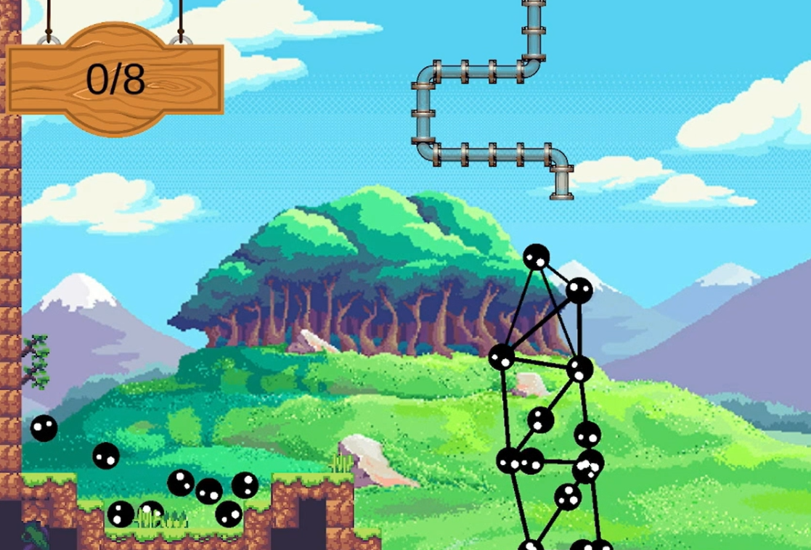

(Robineau, 2023)

Found here : <https://robineau.itch.io/world-of-goo>

-This is physics-based puzzle game where players build structures using balls of goo to bring all your goo to the exit pipe of each level. The goo balls interact and bounce with each other as well as interact with the environment based on realistic physics.

-This is initially where the idea of using gravity to one's advantage came from especially when it came to how players can strategize their building technique to subvert the gravity that already acts on the balls that also make up the entire structure. This invoked the idea of using balls that are acted upon by gravity and how I could influence the behaviour of the balls to create a different game experience to this one. The entire idea revolved around what other ways gravity can manipulated to achieve various objective.  
  
Within the “World of Goo” game I took the mechanics of being able to control balls by clicking and dragging them together to create a structure by re-inventing the same mechanic of controlling the balls, but in my case with the application of the Buoyant Force. The re-interpretation of this mechanic within the context of my game introduces an interesting exploration of the concept of the Buoyant force especially if one is applying the understanding of how buoyancy works within a game (play) experience.

**World of Goo limitations:**

In the World of Goo game, when players get to other levels, there is a visual indicator of a Goo ball counter that lets players know how many balls they have left to build their structure. The counter decreases as layers use up the balls to build their structure. If players use up all their balls before they can finish building their structure, they would then have to restart the level.  
  
Within the context of my game; I decided to use the same limitation or constraint from the World of Goo by also restricting the number of balls players would have to get to the target altitude objective. This means that in some levels, players only have a fixed number of balls they need to use sparingly to ensure that they reach their target altitude objective before the balls available or left run out. If the counter decreases to zero balls and players haven’t managed to reach the set altitude objective for that level, then they would have to restart the level or rather the game will prompt the player to try again until they achieve the set altitude objective.

With the above constraint, I added it with the thought of how it would hopefully introduce a layer of strategy in the game in terms of how it lets players know the way they could use the number of available balls to them sparingly. With the possible event of failure within being able to fully maintain all the balls within the set altitude objective and the very possible occurrence of touching the spikes, I hoped that it would introduce an aspect of replay (ability) in the game. This means that I wanted to emphasize the “forgiving” aspect of the game by simply respawning players to their starting position when their ball touches the spikes or even when the balls eventually run out before the players could win.

•**Bridge Constructor:**

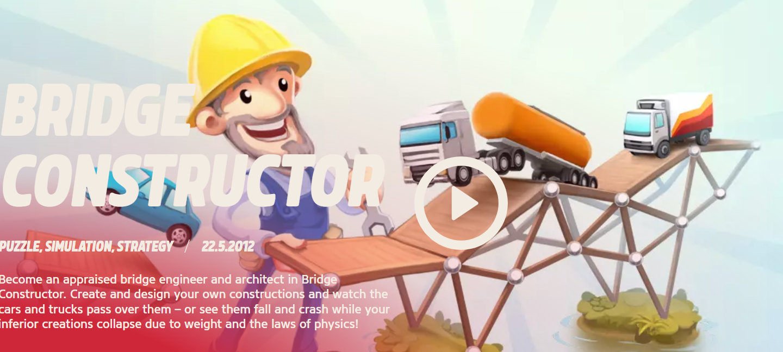

(Clockstone, 2013)

Found here : <https://store.steampowered.com/app/250460/Bridge_Constructor/>

-In the Bridge Constructor series game developed by Clockstone in 2013, players are tasked with implementing their understanding of the laws of physics and weight by creating structures or bridge constructions that cars or different modes of transport will travel on. Players also obtain a score if their bridge can withstand the daily stress and load-bearing level of cars, trucks and tank trucks.

-At its core, the above game tests the players' ability to use the laws of physics to their own advantage to build a structure that an object that has weight and mass will travel on. This understanding of how physics works, particularly with the use of concrete pillars and particular materials used so the structure does not succumb to gravitational forces when travelled on is also one of the origins of my idea in my game. It is fascinating (at least to me ) how players can tap into the trench of their critical thinking skills to simulate behaviour that will act in contradiction to the laws of physics and particularly manipulate them to achieve a desired or set objective within game constraints.  
  
In Bridge Constructor, the consistency of constantly keeping to the same primary mechanic of manipulating the laws of physics to build various structures that different modes of transport will travel on is the takeaway that I also want to embed within my own gameplay. To avoid complicating the system I am trying to create, I have thus decided to use the same consistency and keep to the same main primary mechanic but allow players to use only one mechanic within the whole game.

That is:

-The use of the spacebar key to apply force to the balls of varying sizes and decide how to regulate the thrust force. The latter means how long players decide to hold the spacebar key.

*How will the level design work within your game and how will it align with driving the player to want to do considering what they will be doing?*

Furthermore, to generate a rapid pacing level and a consistent level of difficulty, i have divided my game into 5 levels(as already mentioned). The first 2 levels(Tutorial and level 1) will serve as “Introductory” levels for players to get acquainted with how the main primary mechanic works by actively applying it to progress from each level to the next. Levels 2 to 4, will be the main crux of the game where players will have to overcome obstacles put in place, as well as constraints to achieve the target altitude objective and get rewarded (points) for it.   
As far as level design progression is concerned and how it would align with player motivation, as already expressed, the division of the levels within the game creates the need for players to want to explore , “What’s next?” within the realm of the nature of the main challenge in each level and what the players are supposed to do. As such, I adapted the level design progression in line with the level of difficulty to be found within that level. This means that the level of difficulty proportionally increases as the level design progression and layers of focus in each level increase. As such, this then places the game state in a position where players could potentially be left with a “cliff hanger” that induces them to want to find out what else is there to do or what more is there for them to do. With that said, this streamlines the alignment of the level design progression to how it would also motivate the players to want to do more.

3. Critical Reflection on game development and design:

**Project Plan and changes:**

(For Iteration 2 before the exam game)

**Breakdown of goals in a bit more detail:**

1. Ensure Smooth Gameplay:

- Ensure the game works smoothly without bugs or issues.

2. Focus on Levels 3 and 4:

- Introduce moving obstacles in level 3 that will block the balls from going up. This makes the level require timing management to avoid respawning should the ball touch the spikes of this obstacle.

-Introduce a maze-like field in 2D and add Buoyancy Boosters.

Role of Obstacles:

- Not a Mechanic, but are dynamic obstacles:

- Designed to make the game more challenging by obstructing the player's progress.

- Adds a layer of complexity, requiring strategic thinking to overcome.

Gameplay Impact:

- Increase in Challenge:

- Later levels become more challenging compared to earlier levels.

- Players need to adapt their strategies to overcome the obstacles.

- Buoyancy Regulation and Ball Movement:

- Players need to figure out how to regulate buoyancy while dealing with obstacles affecting altitude targets. Players also have to think about how to balance the movement of the balls while harnessing the regulation of Buoyancy.

Examples:

- In level 3, a moving obstacle periodically blocks the path, requiring careful timing from the player.

- In level 4, multiple obstacles are placed as walls that have spikes on them to create a maze-like environment, increasing the complexity of reaching the altitude targets.

**CHANGES MADE POST ITERATION 2 MARKING, JUST BEFORE THE EXAM:**  
  
**Mechanics and development:**  
-The main mechanic of using space bar to apply the buoyant force to make the balls go up remains unchanged but the only thing I changed was the way with which the Buoyant force is regulated to make the balls go up. From the feedback I received, the action of “smashing” the keyboard or the space bar to constantly apply the force to make the balls go up wasn't an ideal design choice as it caused exhaustion and was physically straining on the hand. As such, I then decided to make it easier for player to control the element of Buoyancy by just easily holding the down the space bar to apply the force to the balls. Not only does that reduce the physical strain on the player’s hand but it also makes it easier to manage as player can decide how long they hold the space bar and in other later levels, they can strategize on where it would be most beneficial to hold the space bar for longer and vice versa.  
  
**Puzzle Gameplay Changes:**

-Considering that I wanted to allow players to gain an understanding of how the Buoyancy works and be able to decide for themselves what way it would benefit the balls to gain enough “thrust” force when needed, I decided to add input control that would allow players to love the ball horizontally and vertically using the arrow keys .  
-The purpose of adding input control for the ball is to allow for the element of puzzle-like gameplay where players think about their actions or set of movement before they can play and they do not just press the space bar throughout the entire game. With the controls, the player can decide how to make the ball move throughout the maze like patterns and most importantly, they also get an opportunity to decide HOW to regulate the Buoyancy to make the balls reach their altitude height. The regulation of Buoyancy within the game is now no longer constant as players are given a platform or challenge to figure out how to get the ball to its target altitude using the regulation of the Buoyant Force.  
- As already expressed , from level 2 to 4, the game view from the player’s POV is a 2D maze like environment that has spikes attached to the edges of the maze (on the sides ). Players then have figure out how to make the ball move a certain way , without getting into contact with the spikes , to make the ball get outside the maze or be closer to the exit point , upon which they can then use the space bar to apply buoyancy to the balls.  
  
In the last level of the game , because the target altitude is the highest compared to the previous levels , I have decided to include “Buoyancy Booster” power up icons that players will collect or that players will make the ball collect. The purpose of the power up boosters are to aid the player in reaching the target objective faster as they multiply the buoyancy already applied to the balls by virtue of holding down the space bar. Not only does it make the already challenging level filled with lots of spikes a bit easier, but it also helps meet the player halfway or provide a “hint” to make the overall gameplay “fun” and worth trying out.  
  
The following is an explanation of some of the areas that make up the strengths and weaknesses of my game:

The game's unique blend of physics-based puzzle gameplay and strategic thinking is a significant strength, offering an engaging and challenging experience for players. The increasing difficulty and obstacles provide a sense of progression and challenge, which is further enhanced by the emphasis on critical thinking and problem-solving skills. However, the limited gameplay mechanics, relying solely on buoyancy and movement, might lead to repetition and potentially detract from the game's overall appeal. Another form of weakness in the game is how it may not fully encapsulate the educational aspect that I may have intended for it to have especially within gameplay. For new players and people who may have never interacted with physics concepts , they may beg to differ but from a personal standpoint, I think that while I do touch on some elements of educational value and the gameplay does lend itself to being a teachable moment for some players , It overall does not fully encapsulate the complexity of what an educational game would entail or fully have. Although I tried researching on how to refine it better, and my research led me to creating separate systems and controls, which would have affected my scope and overall game idea and gameplay expression.

Nonetheless, the design decision to use buoyancy as a core mechanic to manipulate ball behaviour is a notable and effective choice, adding a layer of complexity to the gameplay. The incorporation of a maze-like environment with obstacles and constraints such as the Ball Availability further enhances the game's challenge and requires players to think strategically about ball size, ball movement and buoyancy application. The implementation of a points system to encourage player rewards for strategic thinking and optimization is also one of the “valid” design decisions, as it provides players with a clear goal to work towards and potentially improves the overall puzzle gameplay experience.

4. Playtest Findings and Changes made thereof:

Main Playtest findings:

-With the above changes, the game now has an element of puzzle gameplay where players have an opportunity to figure out the “solution” to make the application of the buoyancy effective for the target altitude objective for each level. Having only playtested with few people, the following are some of the findings and general feedback:  
- One player mentioned that it would be useful to ensure that I only have one element to control the buoyancy even though they can tell that the action of getting the ball up also uses other physics concepts like Momentum and Velocity. This player mentioned that if I wanted to teach players about all these concepts, it would be better to either control all three separately or focus on one specific element and have one way to control it. That way, the latter makes the game more educational for players who don't know how Buoyancy works. The players are challenged to test their understanding by deciding when and how long they would need to apply the force to make the ball reach its target altitude objective without feeling overwhelmed by multiple variables to take note of.  
  
- Another player spoke about how the use of sound within the game makes sense, apart from the balloon pop sound I had every time the players' ball touched the walls or maze spikes. Although I added that sound with the thinking of how it would serve as auditory feedback that the player’s ball has touched the spikes, the playtester said it ended up making the goal of the level confusing. As such, I decided to take it out and replace the feedback message to the player with a text that cautioned them to be careful not to make the ball touch the spikes.

-Another player thought it would be cool if I had camera view that showed the balls as they rise to their altitude objective. It would be an interesting visual cue to show the effect of the buoyancy even more, apart from what I already have which also effectively gets the point across.

Conclusion and Future Plans

The project aimed to design a physics-based puzzle game that conveys the knowledge of buoyancy and gravity to players. Through research, experimentation, and testing, I created a game that meets this goal and allowed players to gain an understanding of how Buoyancy works. The game's mechanics, sound design, and visuals work together to create an engaging and educational experience. Key outcomes include:

- A functional game prototype that demonstrates the application of buoyancy and gravity principles

- A unique sound design approach that uses everyday sounds to convey complex physics concepts

- A visually appealing game world that immerses players in a space/galaxy-themed environment

Future Plans:

To further develop the game, I plan to:

- Refine the game mechanics based on player feedback and testing results

- Expand the game's content to include additional levels, obstacles, and physics concepts

- Explore virtual reality (VR) and augmented reality (AR) possibilities to enhance the game's immersive experience

- Collaborate with physics educators and indigenous communities to ensure the game's accuracy and cultural sensitivity

- Develop a comprehensive evaluation framework to assess the game's effectiveness in teaching physics concepts

By building on the project's progress and outcomes, I aim to create a game that not only engages players but also inspires a deeper understanding and appreciation of physics and indigenous cultures.